PowerSchool Public Portal

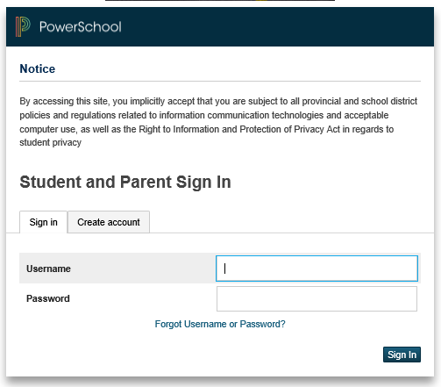
Introduction & Purpose
The PowerSchool Public Portal is an online tool that enables parents and students to become informed and involved partners in Education. The Public Portal can keep you informed about what’s happening at school, track your children’s progress, and provide you with online access to your children’s teachers & classes.
The Public Portal gives Parents/Guardians the very latest student information such as:

- Attendance
- Student Schedules
- Assignments
- School bulletins
- Assignment criteria
- Grades & Assessments
- Teacher comments

Please Note: Parents/guardians and students agree and understand that the PowerSchool Public Portal is offered on a best effort basis. The District cannot troubleshoot home computer issues. Users are responsible for resolving any technical issues encountered when trying to access this system. However, if you experience any further problems with our PowerSchool system, please contact your School Administrator.
Single Sign-on Setup:
PowerSchool’s Public Portal uses a single sign-on process for parents/guardians, which means you now have your own individual parent/guardian account, including your personal user name and password. Your child’s school will provide you with a letter (one letter for each of your children) that contains the following information for your child:
- The Public Portal’s internet address
- Step-by-step directions of how to create your parent account
- How to link children to your account using the Student Access ID & Password
- How to add a student to an existing parent/guardian account
Working with Student Access IDs & Passwords
Create an Account

Follow these steps to create an account for the Public Portal and Link your child(ren) to your account.
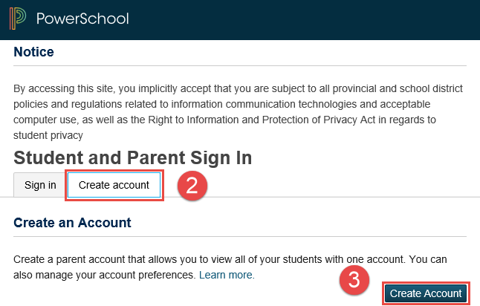
- Enter the website address into your browser (e.g. Google Chrome, Internet Explorer, Firefox etc.)

- Click on Create account tab.

- Click Create Account button.

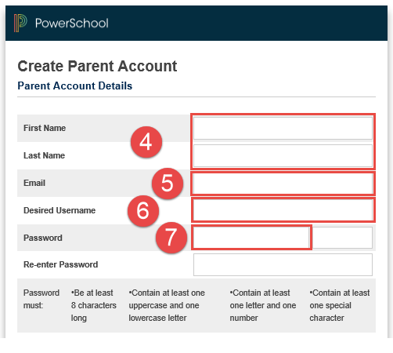
PLEASE NOTE: For your INITIAL login, it is very important to click Create Account. The Student Access ID and Access Password provided to you on the letter from your school is NOT your Username or Password to log into the Parent Portal. You will create your own unique username and password following steps 6 and 7 below.

- Enter your first and last name.

- Enter your email address. This is the email address that all notices from the school are sent. PLEASE NOTE: You must enter a valid email address to create an account.

- Enter a user name of your choice, which you will use each time you Sign-In to the Parent Portal.

- Create a password, your password must include at least:
- A minimum of 8 characters
- 1 upper case letter
- 1 lower case letter
- 1 number
- 1 special character; special characters are the keyboard characters not defined as letters, numerals or spaces. They include:
` ~ ! @ # $ % ^ & * ( ) _ - + = { } [ ] \ | : ; " ' < > , . ? /
Password tips:
- Do not write your password down
- Do not share your password with anyone
- Do not use common words or information about you that can be easily obtained about you. This includes usernames, birthdates, license plates, telephone numbers, etc.

Linking Your Children to Your Parent Account
You can add one or more children the first time you create your account. To link to multiple children you must have a Web Access Letter for each child. If you have all the necessary letters follow the steps here. If you have only one letter but receive a second letter at a later date, enter the first child now and then follow the steps in the section Linking Additional Children after Your Account Has Been Created to add the new child.
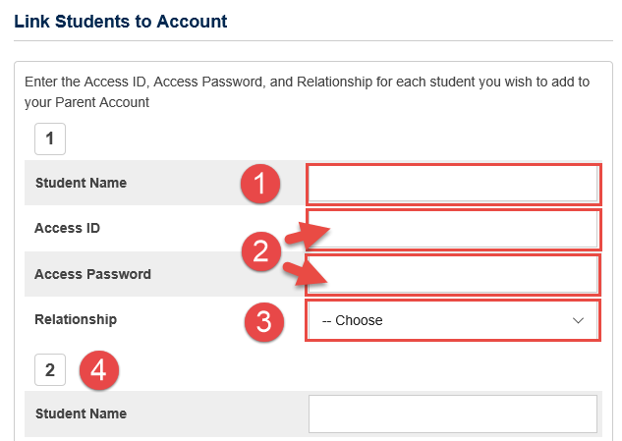
- Enter the name of your child exactly as it is printed on the letter from the school. Each child should be setup individually.
- Enter the Student Access ID and Access Password for your child, as per the letter from the school.
- Select your relationship to the child from the drop-down list.
- If you have more than one child, repeat steps 1 to 3 for the next child in the next section.

Select Enter.

Once you submit the information to create your account, you will return to the log in page.

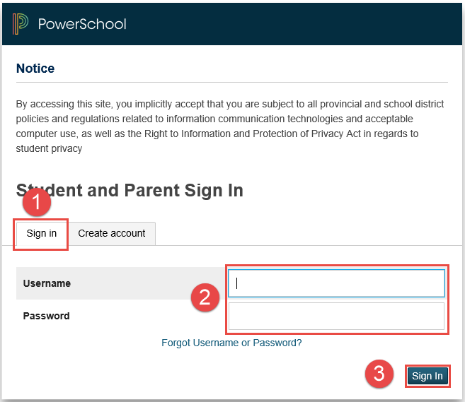

- Make sure you are on the Sign in tab.
- Enter the Username and Password you created when creating your Public Portal account.
- Click Sign In.

Linking Additional Children after Your Account Has Been Created

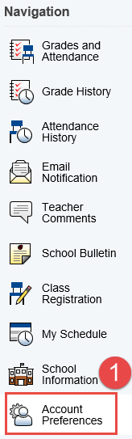
The steps described here are for adding more children after your account has been created.

Log into your Public Portal Account.

- On the left hand side of the Public Portal Homepage, click Account Preferences.

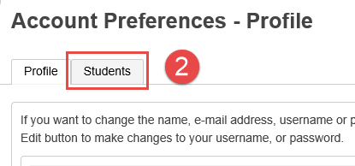

- Select the Students tab.

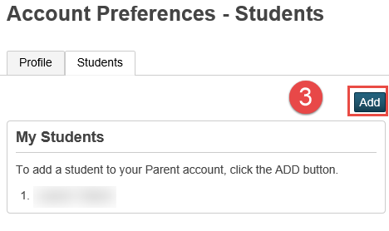

- Click Add to enter the information for your additional child.

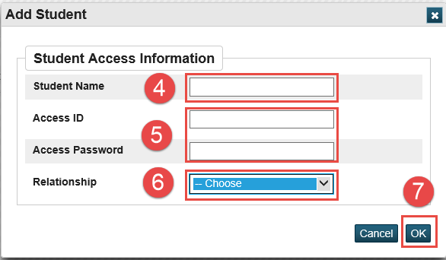

- Fill in your child’s name exactly as it is on the Web Access letter.
- The ID and Password are provided in the letter.
- Select your relationship to the child.
- Click OK.

Parent Sign Off

Please note: While stringent security protocols are enforced to mitigate the risk of unintentionally exposing student information to the internet, any information hosted on websites or e-mailed has the potential to be viewed/accessed by other Internet users. Parents & students are advised to consider this possibility and strictly adhere to the Acceptable Computer Use Policy guidelines.

